  - Global Data Privacy and Cybersecurity Handbook

Contents
To generate table of contents, right-click here and select Update Field.

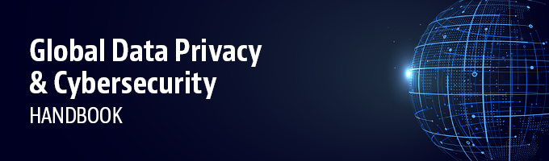
Managing opportunity and risk in an information-driven digital world
Data is a critical asset in today’s globally connected economy. Rapidly evolving technologies have made it easier than ever for companies to collect, use and transfer data throughout the world. Yet strict data protection, privacy and cybersecurity regulation is evolving rapidly, imposing complex and often inconsistent standards.
We can help companies to navigate the myriad of challenging data protection, privacy and cybersecurity laws, regulations and guidance, in all regions globally where our team of experts are ready where you need us.
Our Global Data Privacy & Cybersecurity Handbook is updated annually to help you keep up with the dynamic legal landscape. We provide detailed overviews and allow a comparative perspective of the increasingly complex and sophisticated data privacy and security standards in over 50 countries.
Please click the links at the top of this page to "select a jurisdiction" of interest or "start comparison" to experience a comparative view.
View all related professionals here.

