  - Fighting Domestic Violence - Cameroon

Contents
To generate table of contents, right-click here and select Update Field.

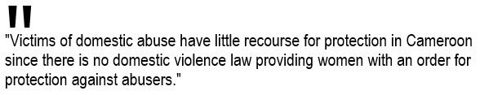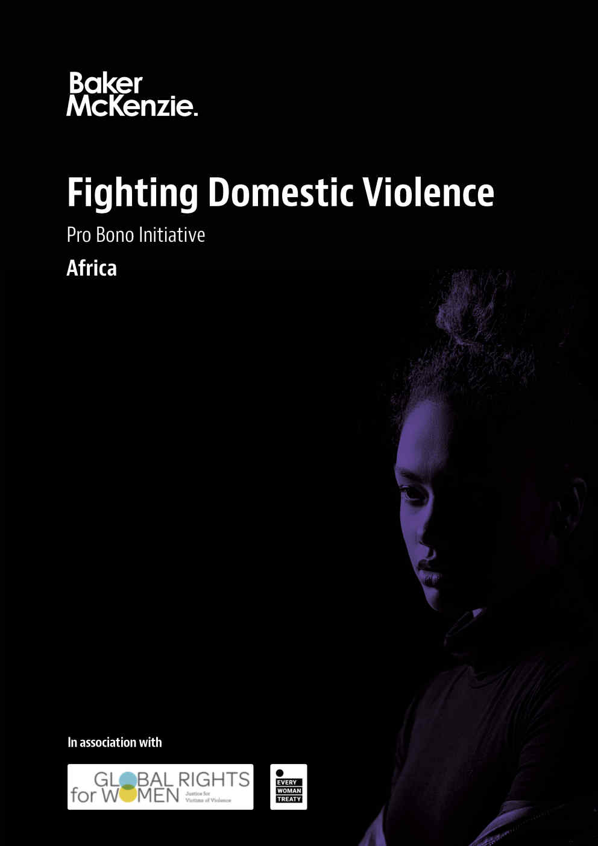
Cameroon Full Report
How to use and navigate this report

1. Legal provisions

1.1 What are the relevant statutes and codes?
Victims of domestic abuse have little recourse for protection in Cameroon since there is no domestic violence law providing women with an order for protection against abusers.
However, several international codes and conventions are intended to give some scope of protection to the victims and certain articles of the Cameroonian Penal Code can be applied to domestic violence.
International level
Universal Declaration of Human Rights of 1948
The Convention on the Elimination of all Forms of Violence and Discrimination Against Woman adopted by the United Nations in 1979
Vienna Declaration and Programme of Action of the World Conference on Human Rights of June 1993 (A/Conf.157/25) and the Declaration on the Elimination of Violence Against Women adopted by the General Assembly of the United Nations in Resolution 48/104 of 20 December 1993
Fourth World Conference on Women (Beijing, 1995)
African Charter on Human and Peoples' Rights with special emphasis on the rights of women adopted in Maputo in 2003
National level
Ministry for the Protection of the Family and the Woman, created in 2004
Cameroonian Penal Code
a family code was drafted in 1997 to address issues of domestic violence but it has still not been adopted

1.2 What is the controlling case law?
There is no available case law in Cameroon regarding domestic violence. However, the codes and conventions mentioned in Section 1.1 and the Ministry for the Protection of the Family and the Woman ensure that "all acts of violence and discrimination against women are reported and that the police force receives support in caring for and assisting in the reintegration of women victims of violence into society and their families." The reality is that domestic violence in Cameroon is still considered a private matter and the law enforcement officers do not consider it a serious issue; therefore, victims are reluctant to report abuse. Furthermore, the Cameroonian judicial system usually applies customary rules that discriminate against women (it is considered that a man has "disciplinary rights" over his wife) and judges are usually reluctant to apply international legal instruments ratified by Cameroon.

1.3 What are the specific parts of the court system that address domestic violence?
As there is no special law regulating domestic violence, victims may file a complaint under the assault provisions of the Cameroonian Penal Code. Therefore, the criminal courts will judge this type of violence.

1.4 What are potential causes of action?
As previously mentioned in Section 1.3, domestic violence issues will be treated as criminal proceedings.

2. Introduction: framework guiding domestic violence law

2.1 Are there civil and criminal legal remedies for domestic violence victims?
Only criminal legal remedies are available for domestic violence victims.

2.2 Is domestic violence identified in national law as a human right (noting that at a European level protection from domestic violence has not been explicitly identified as a human right but is indirectly captured by the other provisions)?
No, domestic violence is not expressly regulated in the national law of Cameroon. The only national law that can be applicable in cases of domestic violence is the Cameroonian Penal Code, which regulates sexual offenses such as rape, assaults, forced marriage and moral dangers, but none is treated as a violation of human rights.

2.3 Has your country signed and ratified the Council of Europe's Istanbul Convention (2011) preventing and combating violence against women and domestic violence (CETS No. 210)?
No.

2.4 If it has ratified the Istanbul Convention, how has this convention been implemented into national law?
There is no provision for ratification.

2.5 If it has not ratified or signed the Istanbul Convention, is it envisaged that your country will do so?
There is no provision for ratification.

2.6 If it has ratified the 1979 Convention, how has the recommendations part of General Comment No. 35 been implemented into national law?
Yes, Cameroon ratified the 1979 Convention on the Elimination of All Forms of Discrimination Against Women on 23 August 1994, but Cameroon has not ratified the Optional Protocol to the Convention on the Elimination of All Forms of Discrimination Against Women.
In Cameroon, human rights instruments are generally incorporated into national law simply by means of ratification. Article 45 of the Constitution of Cameroon states that duly approved or ratified treaties and international agreements have priority over national law. Nonetheless, in practice, as previously mentioned, judges are reluctant to apply international legal instruments and they usually invoke national or customary laws.

2.7 If the 1979 Convention has not been ratified or signed, is it envisaged that your country will do so?
N/A

3. Similarities and differences in terminology

3.1 Domestic violence
There is no specific definition.

3.2 Stalking
There is no specific definition, but invading residences and tampering with correspondence are criminalized in Articles 299 and 300 of the Cameroonian Penal Code.

3.3 Harassment
Article 302-1 (1) of the Cameroonian Penal Code states the following about sexual harassment:
Whoever takes advantage of the authority conferred on him by his position to harass another using orders, threats, constraints or pressure in order to obtain sexual favours, shall be punished.
No other sexual harassment provision is mentioned in the code.

3.4 Victim
There is no specific definition.

3.5 Abuser
There is no specific definition in the Cameroonian Penal Code and it is more often referred to as an "offender" or "perpetrator." However, Article 307(1) of the Cameroonian Penal Code states the following about abuse:
Whoever uses without having been provoked against any person in the circumstances of publicity described in Article 152 any insulting expression, or contemptuous gesture or words, or invective without imputation of fact, shall be punished.
This can be understood as an implicit definition of an abuser.

3.6 Civil protection order
There is no specific definition.

3.7 Causes of action
There is no specific definition.

3.8 Marital rape
There is no specific definition.

3.9 Are there any other important domestic violence terms defined in relevant domestic violence statutes and codes?
There are no specific regulations about domestic violence and no relevant terms are defined in domestic legislation. Domestic violence victims need to rely on the definitions provided for standard violent crimes, specifically rape and abuse.

4. Protection for domestic violence victims and relief granted

4.1 Civil protection orders

4.1.1 Are there civil protection orders available to victims of domestic abuse?
No. Civil protection orders are not available to victims of domestic abuse in Cameroon. Domestic abuse/violence is not recognized as a specific crime in Cameroon and protective/safety orders are not available to victims.
Victims would have to file a complaint against the abuser under the assault provisions of the Cameroonian Penal Code: Article 277 (grievous harm); Article 279 (assault occasioning grievous harm); Article 280 (simple harm); Article 281 (slight harm); Article 338 (assault on a woman with a child); or Article 350 (assault on children). Rape (Article 296), forced marriage (Article 356) and abuse in respect of a "bride price" (Article 357) are also offenses under the Cameroonian Penal Code.
Domestic abuse is seen as a private matter by law enforcement agencies in Cameroon. Even if a case proceeds to court (it is reported that few cases reach this stage), judges generally accept that a man has "disciplinary rights" over his wife. It is also reported that while the state operates helplines for victims, no shelters are available for victims.

4.1.2 Who can petition for civil protection orders?
N/A (see section 4.1.1).

4.1.3 Are there temporary custody of a child or child support orders?
No. Civil protection orders are not available.

4.1.4 Is there a provision to order the abuser to move out or stay away from places that the victims frequent?
No. Civil protection orders are not available.

4.1.5 Are there any other types of emergency, preventive and civil protection orders?
No. Civil protection orders are not available.

4.1.6 Can these orders be requested by direct or indirect victims or legal representatives in children's cases?
N/A (see section 4.1.1).

4.1.7 Are there different types of civil protection orders, e.g., for a short- term period?
No. Civil protection orders are not available.

4.1.8 Are ex parte orders permitted without the aggressor being present?
No. Civil protection orders are not available.

4.1.9 Do emergency orders also extend protection for abuse and intimidation to family members of the victim?
N/A. Civil protection orders are not available.

4.1.10 How long do the orders last?
N/A. Civil protection orders are not available.

4.1.11 Please provide any data or hyperlinks to government or NGO websites that include information on how often civil protection orders are issued, and any relevant demographics information, e.g., police reports, convictions, etc.
Between 2006 and 2008, 3,680 cases of physical violence against women (including domestic violence) and 2,500 cases of psychological violence were recorded by the government's services. There are no statistics on how many of those cases resulted in prosecution or conviction.

4.2 Steps for receiving a protective order

4.2.1 What documentation is needed to obtain a civil protection order?
N/A. Civil protection orders are not available.

4.2.2 Does the victim need to attend a hearing?
N/A. Civil protection orders are not available.

4.2.3 Can you request remedies?
N/A. Civil protection orders are not available.

4.2.4 Are there time limits?
N/A. Civil protection orders are not available.

4.2.5 Are there different rules in emergencies?
N/A. Civil protection orders are not available.

4.3 Judicial discretion

4.3.1 What discretion does a judge have in granting a civil protection order or other protective orders?
N/A. Civil protection orders are not available. However, if a criminal prosecution proceeds to court, judges generally accept that a man has "disciplinary rights" over his wife.

4.3.2 Are there age limits on who can obtain orders?
N/A. Civil protection orders are not available.

4.4 Restitution and remedies available to victims

4.4.1 Can victims obtain reimbursement for costs and restitution paid?
No.

4.4.2 Can they recover wages and profits lost?
No.

4.4.3 Is a separate civil process required?
N/A

5. Prosecutorial considerations

5.1 Police procedures

5.1.1 When do the police get involved in domestic disputes or legal actions?
While there is no specific legislation on this, it appears that the police rarely intervene in domestic violence disputes as they see them as "private matters." The victim can be seen by the police to be responsible for the violence and they may be sent back to the abuser. The Ministry for the Protection of the Family and the Woman apparently views domestic violence as a waste of time.

5.1.2 What circumstances effect law firm involvement?
Pursuant to the previous point, there is little involvement of law firms in Cameroon for domestic violence cases. They might be involved in cases of mediation, a tool sometimes used to solve domestic violence cases.

5.2 Standard of proof

5.2.1 Is proof required by any legal means?
Article 308(a) of the Cameroonian Penal Procedure Code states, "Except where otherwise provided by law, an offence may be established by means of proof." There does not seem to be exceptions for offenses that may be assimilated into domestic violence (as there is no specific offense for domestic violence).

5.2.2 Are there any requirements regarding evidence and documents?
There are specific requirements for types of evidence. Article 308(c) states, "Proof by means of wire tapping, electronic listening devices or other instruments of surveillance is admissible under the conditions laid down in Articles 92 and 245," which are specific provisions that authorize or order such means.
Moreover, Articles 313 and 314 of the Cameroonian Penal Procedure Code establish that the content of documents can only be proved with the primary evidence, meaning the original document (or documents if several copies are made with a mechanical process), except in certain situations in which secondary evidence is accepted (a copy of the original document certified by a competent authority). Secondary evidence is only admitted in the following cases:
when it is established before the court that the original is in the possession of the adverse party or a third party that refuses to produce the document after a notice is served
when the existence and the contents of the original are not disputed by the adverse party
when it is established that the original has been destroyed or lost
when the original cannot be easily moved

5.2.3 Is proof "beyond a reasonable doubt" required?
Yes. Article 395 of the Cameroonian Penal Procedure Code states that in case of doubt, the accused will be acquitted. A reference to the benefit of doubt will be made in the judgment.

5.2.4 Is the standard of proof different for ex parte orders?
No.

5.3 Affirmative defenses

5.3.1 Are affirmative defenses available to the accused?
Yes. See Part 3, Chapter II of the Cameroonian Penal Procedure Code, which lists the following affirmative defenses:
insanity
intoxication
infancy
threats
compulsion
obedience to a lawful authority
lawful defense
provocation if the answer to the provocation is proportionate
state of necessity
effect of diminished responsibility

5.3.2 Is willful intent required?
Yes, as a principle (Article 74 of the Cameroonian Penal Procedure Code), unless the law states otherwise, which is the case for some crimes falling under the qualification of domestic violence, such as assault occasioning death, assault occasioning grievous harm, simple harm and slight harm (Articles 278-281 of the Cameroonian Penal Code).

5.3.3 Are false accusations punishable for the victim?
Yes, as regulated in Article 260 of the Cameroonian Penal Procedure Code. A defendant in whose favor a no-case ruling is made and that has become final may institute an action for false reporting. They may also sue for damages before the competent trial court. In case of a conviction, the costs will be borne by the civil party.

5.3.4 How is consent discussed in the law?
There is no strict definition of consent, but Article 296 of the Cameroonian Penal Code defines "rape" as "sexual intercourse to which a person is compelled, by force or by moral ascendency."

5.3.5 Is self-defense or insanity a defense?
Yes, as regulated in Articles 78 and 84 of the Cameroonian Penal Code. For self-defense, the means of defense need to be proportionate to the seriousness of the infringement threatened. Intentional killing is always considered proportionate to an attack causing a reasonable apprehension of death, of grievous harm, of rape or of sodomy.

5.4 Witness status

5.4.1 What is a witness's duty to testify honestly and completely?
As regulated in Article 183 of the Cameroonian Penal Procedure Code, a witness has to take an oath ("I swear to say the truth, all the truth and only the truth"). If this oath is broken, they may be sentenced to between one and five years of prison.

5.4.2 Who may abstain from testifying in certain situations?
There are no specific exceptions for domestic violence victims. The only applicable general exception is to receive a testimony outside of court due to severe health issues.

5.4.3 What potential "excuses" can a witness raise to refuse to testify in a domestic violence action?
There is none.

5.4.4 What is the impact of domestic violence on witnesses who are children?
No.

5.4.5 Can children be called upon to testify?
Anyone who is 14 years old or older can testify. Nonetheless, if the minor is the victim, they can be heard as a witness, whatever their age. Defendants can be heard at any stage of the prosecution.

5.4.6 What is the effect of a child victim on the charges against the offender?
It depends on the charge, but it appears that there are some applicable alternatives depending on each case. The penalty can be doubled or it can become a life sentence, or even the death penalty may apply. For example, Article 350 of the Cameroonian Penal Code provides that for murder, capital murder and assault occasioning death, the penalty when the victim is a child is either a life sentence or the death penalty. In the case of assault occasioning grievous harm, simple harm and slight harm committed on children, the charges will be doubled.

5.5 Penalties and sentencing; penalty enhancements

5.5.1 What are the penalties and sentencing laws for first-time domestic violence offenses?
N/A

5.5.2 Are there criminal penalties?
N/A

5.5.3 What is the result of a violation of an existing order for protection?
N/A

5.5.4 What fines and other penalties are imposed besides incarceration and liberty restriction?
N/A

5.6 Post-release restrictions

5.6.1 Does the law notify the victim of the offender's release from custody?
No.

6. Special issues

6.1 Battered woman syndrome

6.1.1 Can lawyers present evidence of battered woman syndrome or other domestic abuse as an affirmative defense to crimes that the battered woman has committed? (Note: Battered Woman Syndrome is accepted by courts in certain jurisdictions to show that battered women can use force to defend themselves and sometimes kill their abusers due to abusive and life-threatening situations.)
There is no specific regulation in this regard and, for the most part, domestic violence cases are not reported. Considering that most judges consider domestic violence a private matter and that men have disciplinary rights over their spouses, no evidence of battered woman syndrome is used by lawyers.

6.2 Domestic violence in the workplace

6.2.1 Can courts issue orders to protect employees suffering from domestic violence?
There is no specific legislation in this area.

6.2.2 Can departure be deemed "for good cause" if related to domestic violence?
There is no specific legislation in this area.

6.2.3 Can family members of domestic violence victims take reasonable leave to help the victim seek treatment or obtain help and services?
There is no specific legislation in this area.

6.3 Immigration

6.3.1 Does the law include provisions that are intended to prevent abusers who are citizens or permanent residents from using immigration laws to perpetrate domestic violence against their spouse?
There is no specific legislation in this area.

6.3.2 If battered immigrants cooperate with law enforcement in domestic violence, can they obtain immigration remedies?
There is no specific legislation in this area.

6.3.3 Does domestic violence law discuss asylum accessibility?
There is no specific legislation in this area.

6.4 Armed forces

6.4.1 Can a victim seek a military protective order if the abuser is in active military?
There is no specific legislation in this area.

6.5 Child custody and child/spousal support

6.5.1 Do judges follow special rules to determine custody or visitation of children in domestic violence cases?
There is no specific legislation in this area.

6.5.2 Can the judge consider the testimonies of the other spouse and the children when determining custody?
There is no specific legislation in this area. As previously stated, generally, anyone who is 14 years old or older can testify. Nonetheless, if the minor is the victim, they can be heard as a witness, whatever their age.

6.6 Housing rights of domestic violence victims

6.6.1 Does the law include any barriers to prevent landlords from forcing a tenant to move out because they are victims of domestic violence?
There is no specific legislation in this area.

6.6.2 Does the law allow a tenant to terminate his/her lease early due to domestic violence?
There is no specific legislation in this area.

6.6.3 Can an order exclude the abuser from the residence?
There is no specific legislation in this area.

6.6.4 Can abusers be forbidden by court orders to alienate or mortgage the property in his/her name if it is the family domicile?
There is no specific legislation in this area.

©Copyright © 2024 Baker & McKenzie. All rights reserved. Ownership: This documentation and content (Content) is a proprietary resource owned exclusively by Baker McKenzie (meaning Baker & McKenzie International and its member firms). The Content is protected under international copyright conventions. Use of this Content does not of itself create a contractual relationship, nor any attorney/client relationship, between Baker McKenzie and any person. Non-reliance and exclusion: All Content is for informational purposes only and may not reflect the most current legal and regulatory developments. All summaries of the laws, regulations and practice are subject to change. The Content is not offered as legal or professional advice for any specific matter. It is not intended to be a substitute for reference to (and compliance with) the detailed provisions of applicable laws, rules, regulations or forms. Legal advice should always be sought before taking any action or refraining from taking any action based on any Content. Baker McKenzie and the editors and the contributing authors do not guarantee the accuracy of the Content and expressly disclaim any and all liability to any person in respect of the consequences of anything done or permitted to be done or omitted to be done wholly or partly in reliance upon the whole or any part of the Content. The Content may contain links to external websites and external websites may link to the Content. Baker McKenzie is not responsible for the content or operation of any such external sites and disclaims all liability, howsoever occurring, in respect of the content or operation of any such external websites. Attorney Advertising: This Content may qualify as “Attorney Advertising” requiring notice in some jurisdictions. To the extent that this Content may qualify as Attorney Advertising, PRIOR RESULTS DO NOT GUARANTEE A SIMILAR OUTCOME. Reproduction: Reproduction or copying of the Content on this Site without express written authorization is strictly prohibited.

