  - Global Sustainable Buildings Index

Contents
To generate table of contents, right-click here and select Update Field.

GLOBAL SUSTAINABLE BUILDINGS INDEX
This content was last reviewed around March 2016. All content is for informational purposes only and may not reflect the most current legal and regulatory developments. All summaries of the laws, regulations and practice are subject to change.
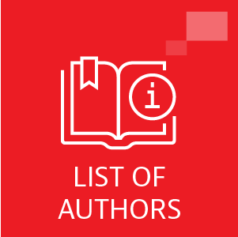
Please note this index was published in March 2016.

©Copyright © 2024 Baker & McKenzie. All rights reserved. Ownership: This documentation and content (Content) is a proprietary resource owned exclusively by Baker McKenzie (meaning Baker & McKenzie International and its member firms). The Content is protected under international copyright conventions. Use of this Content does not of itself create a contractual relationship, nor any attorney/client relationship, between Baker McKenzie and any person. Non-reliance and exclusion: All Content is for informational purposes only and may not reflect the most current legal and regulatory developments. All summaries of the laws, regulations and practice are subject to change. The Content is not offered as legal or professional advice for any specific matter. It is not intended to be a substitute for reference to (and compliance with) the detailed provisions of applicable laws, rules, regulations or forms. Legal advice should always be sought before taking any action or refraining from taking any action based on any Content. Baker McKenzie and the editors and the contributing authors do not guarantee the accuracy of the Content and expressly disclaim any and all liability to any person in respect of the consequences of anything done or permitted to be done or omitted to be done wholly or partly in reliance upon the whole or any part of the Content. The Content may contain links to external websites and external websites may link to the Content. Baker McKenzie is not responsible for the content or operation of any such external sites and disclaims all liability, howsoever occurring, in respect of the content or operation of any such external websites. Attorney Advertising: This Content may qualify as “Attorney Advertising” requiring notice in some jurisdictions. To the extent that this Content may qualify as Attorney Advertising, PRIOR RESULTS DO NOT GUARANTEE A SIMILAR OUTCOME. Reproduction: Reproduction or copying of the Content on this Site without express written authorization is strictly prohibited.

