  - Fighting Domestic Violence - Switzerland

Contents
To generate table of contents, right-click here and select Update Field.

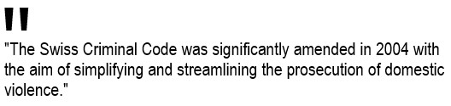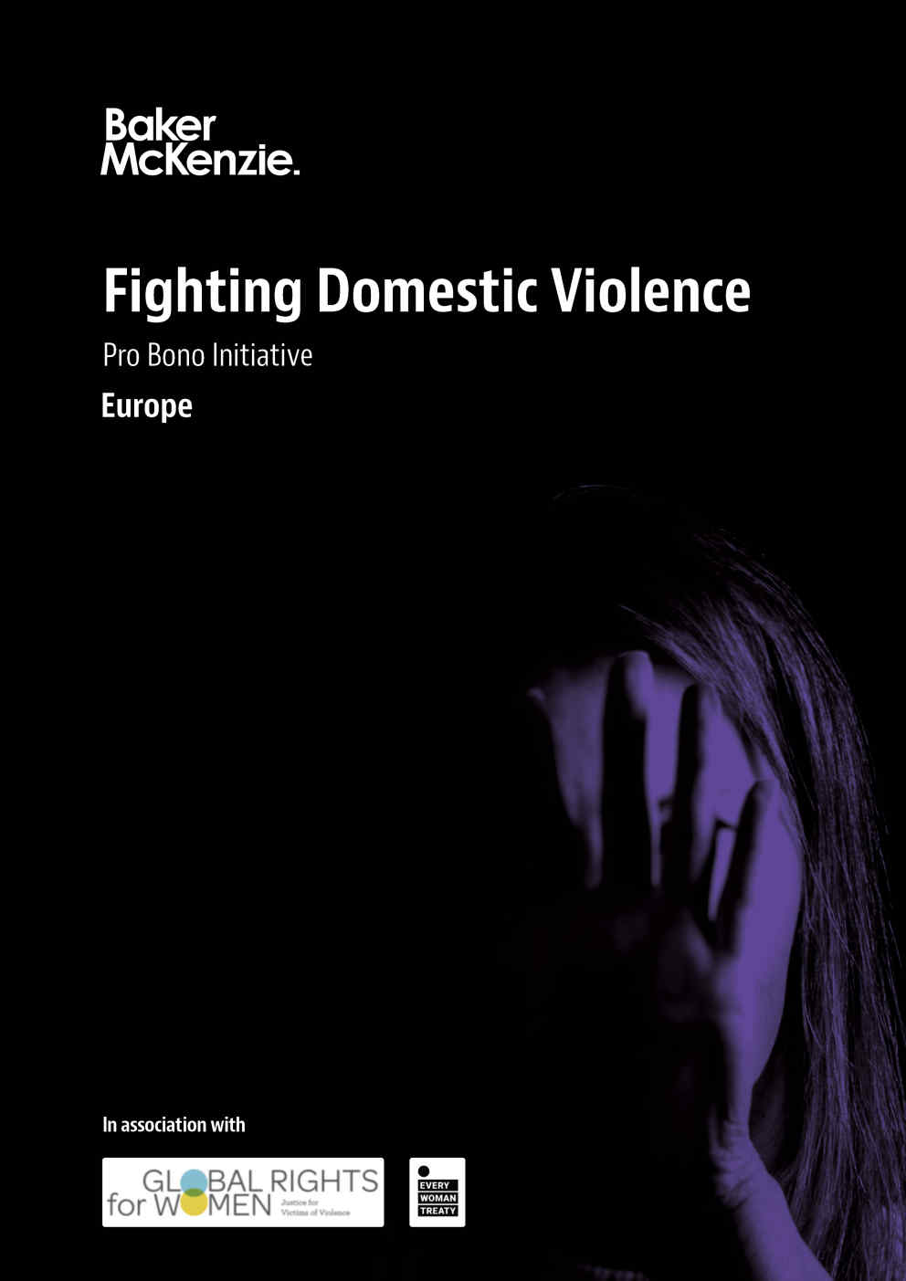
Switzerland Full Report
How to use and navigate this report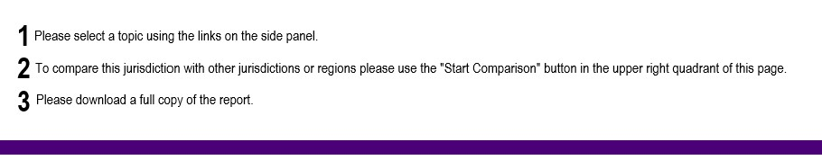

1. Legal provisions

Introduction
The aim of this overview is to provide a consolidated review of national domestic violence legislation and enforcement mechanisms in Switzerland and how these relate to the broader obligations under international legal frameworks, in particular the Council of Europe Convention on preventing and combating violence against women and domestic violence ("Istanbul Convention").
Switzerland has taken a number of positive steps to combat domestic violence. The Swiss Criminal Code was significantly amended in 2004 with the aim of simplifying and streamlining the prosecution of domestic violence. There are also a number of civil law provisions that are intended to further protect victims. Following the adoption of the Istanbul Convention in December 2017, Switzerland introduced further amendments to both its civil and criminal laws in order to bring the national legal framework more in line with the principles of the convention. There have also been a number of positive developments with respect to on-the-ground enforcement, including the establishment of specialized police units as well as an increase in reports and prosecutions.
Notwithstanding these positive developments in both the legislative and enforcement spheres, significant concerns still exist. For example, nongovernmental organizations (NGOs) continue to report that violence against women remains a serious problem in Switzerland. According to a report from NGO Amnesty International in 2019, one in five women and girls over the age of 16 have been subjected to sexual violence in Switzerland, and more than 10% of women and girls surveyed had been raped. Of those surveyed, only 8% reported the assault to the police.^{[1]} NGOs have further raised concerns regarding increased demand for domestic violence services and shelters. Lastly, whereas the most recent amendments to Swiss law aimed to bring it in line with the requirements of the Istanbul Convention by streamlining legal procedures, it can be argued that the amendments do not yet go far enough to protect and support the victims of domestic violence.
The status quo: overview of existing Swiss laws
In Switzerland, the national law can be divided into the federal level and the cantonal^{[2]} level of the individual states. Swiss domestic violence legislation is primarily governed at the federal level and is examined more closely below.
1. Intervention measures — Swiss Criminal Code (Strafgesetzbuch, (StGB))
Recent changes to Switzerland's criminal legislation shows a paradigm shift in society's attitude towards domestic violence. In order to protect victims of domestic violence, the private lives of individuals are no longer exempt from state intervention. This shift suggests that society has recognized the particularly serious nature of violence within marriage and partnerships.
In April 2004, the Swiss Criminal Code^{[3]} was amended to expand the prosecution of domestic violence for individuals who are both in and not in relationships.
Individuals in relationships
The prosecution of domestic violence for individuals who are in relationships includes the prosecution of simple bodily harm,^{[4]} repeated assault^{[5]} and threats^{[6]} that occur between spouses or registered partners during the marriage or partnership, or up to one year after the divorce or dissolution of the partnership. The same provisions apply to civil partnerships^{[7]} for an indefinite period or up to one year after their separation. Before this change, the relevant offences were only prosecuted if the victim had filed a formal criminal complaint. Following the amendments to the Swiss Criminal Code on 1 April 2004, officials are obliged to prosecute if there are indications that domestic violence is occurring,^{[8]} irrespective of whether the victim has filed a formal complaint. Indications could, for example, include reports from a neighbor who raises concerns. The amendments to the Swiss Criminal Code also mean that violence in intimate relationships can no longer be viewed as a "purely private matter."
Problematically and as highlighted by Amnesty International, however, certain offences of a sexual nature allow for penal leniency where the victim is a spouse or registered partner of the offender.^{[9]} The potential for such penal dispensation may be construed as treating such offences in the context of domestic violence as being, as Amnesty International phrases, "lesser offence[s] than rape under Swiss law."^{[10]}
Individuals not in relationships
Irrespective of relationship status, sexual assault and rape have always been prosecuted as official offences, albeit on the basis of force rather than consent. Offenders who commit sexual assault can receive a custodial sentence not exceeding 10 years or a monetary penalty. Offenders who commit rape may receive a custodial sentence of between one and 10 years. For both offences, if the offender acts with cruelty or uses a weapon or other dangerous object, there is a mandatory minimum custodial sentence of three years. As with those in relationships, officials are obliged to investigate cases where indications of such offences are present, even if a formal complaint has not been raised by the victim.
2. Protective measures — Swiss Civil Code (Zivilgesetzbuch, (ZGB))
Article 28b, paragraph 1, lit 1-3 of the Swiss Civil Code^{[11]} contains a non-exhaustive list of protective measures to prevent the infringing person from the following:
approaching the plaintiff or coming within a certain radius of their home
staying in certain places, in particular certain streets, squares or neighborhoods
contacting the plaintiff in any way
If the victim lives with the offending person, the court can order the offending person to be removed from the home for a certain period of time. The law does not specify a time limit on these measures and leaves it to the court of first instance to prescribe a time-limit.
The court may also impose a compensation order on the plaintiff for exclusive use of the home.^{[12]} This means that the plaintiff may be ordered to monetarily compensate the offending party for the duration of their forced time from the home. Given the causal link between poverty and the experience of domestic violence,^{[13]} this provision is problematic as it might hinder victims from taking legal action against the offending partner by ostensibly punishing the victim.
3. Support measures — Victims Support Act (Opferhilfegesetz, (OHG))
In 2007, the Victims Support Act^{[14]} entered into force. It obliges the Swiss cantons to provide counselling and information centers to victims. The definition of "victim" in the Victims Support Act has the same meaning as in the Swiss Criminal Code, i.e., it encompasses victims of all crimes including victims of domestic violence. It also allows family members of the victim to seek support. According to Article 2 OGH, the support may not be limited to counselling and emergency aid, but it must include financial relief and long-term support. Whether this financial relief could be used to offset the problematic compensation provision contained in the ZGB (i.e., a plaintiff must compensate the offending party for exclusive use of the home while the offending party has been removed by a court order) is unclear, but would merit further investigation.
4. Integration and domestic violence — Foreign Nationals and Integration Act (Ausländer- und Integrationsgesetz, (AIG))
The Foreign Nationals and Integration Act^{[15]} regulates the entry and exit, residence and family reunification of foreign nationals in Switzerland. In addition, it regulates measures for encouraging their integration. Article 50(1)(a) and (b) AIG regulates the right to grant and renew the residence permit after the dissolution of a marriage^{[16]} or family community.^{[17]} One reason for a spouse and their children to be granted a residence permit and/or to have their residence permit extended is, among others, when "important personal reasons" make an extended residency in Switzerland necessary. Although and according to the Federal Supreme Court domestic violence committed by a spouse can be considered to be an important personal reason, the threshold for this exception is rather high. Only when the victim is "seriously in danger and the relationship has become unbearable" might it qualify as an important personal reason.^{[18]} The Swiss Federal Office for Gender Equality published a scientific report criticizing this decision. The report particularly states that "intensity" as a criteria could lead to the wrong assumption that domestic violence is primarily built on physical factors.^{[19]}
Moreover, Switzerland has expressly excluded Article 59 (which provides protection for domestic violence victims whose residence status depends on that of their partners) and Article 44, Paragraph 1(e) (which provides that a signatory will take necessary measures where an offence is committed by a person who has their habitual residence in their territory) of the Istanbul Convention,^{[20]} providing further evidence that Switzerland is not yet ready to make sweeping reforms in this area.^{[21]}

2. Introduction: framework guiding domestic violence law
Switzerland ratified the Istanbul Convention in December 2017, with force from April 2018.^{[22]} Subject to the right of a signatory to exclude the adoption of certain tenants of the Istanbul Convention,^{[23]} the Istanbul Convention provides a uniform framework with respect to bolstering the prevention and prosecution of, and the protections against, domestic violence across signatories in a number of specific ways.
In addition to excluding Article 44, Paragraph 1(e) and Article 59 of the Istanbul Convention, Switzerland reserved its right to exclude the implementation of the following:^{[24]}
Certain provisions of Article 44, Paragraph 3 of the Istanbul Convention that provide, with respect to sexual violence against adults and to forced abortion and forced sterilization, that signatories must ensure their enforcement.
For the prosecution of the offences established in accordance with Articles 36, 37, 38 and 39 of this Convention, parties will take the necessary legislative or other measures to ensure that their jurisdiction is not subordinated to the condition that the acts are criminalized in the territory where they were committed.
Article 55, Paragraph 1, regarding minor offenses (Article 35 of the Convention) — "Ex parte and ex officio proceedings. Parties shall ensure that investigations into or prosecution of offences established in accordance with Articles 35, 36, 37, 38 and 39 of this Convention shall not be wholly dependent upon a report or complaint filed by a victim if the offence was committed in whole or in part on its territory, and that the proceedings may continue even if the victim withdraws their statement or complaint."
As a result of the Istanbul Convention, the Federal Council proposed various amendments to the civil and criminal laws regarding domestic violence for consultation. On 3 July 2019, the Federal Council put corresponding changes in civil and criminal law into force as per 1 July 2020. The changes will affect the Civil Code (ZGB) and the Code of Civil Procedure (ZPO), the Criminal Code (StGB) as well as the Military Criminal Code (MStG). The new provision in the Civil Code will not enter into force until 1 January 2022 in order to allow the cantons to put in place the necessary preparations within a reasonable time. Whereas the amendments to these laws have already passed, there is arguably still room to influence their interpretation and development via case law or future amendments.
In the Civil Code (ZGB), the new Article 28c will enter into force on 1 January 2022. The court may then, at the request of the plaintiff, order the use of an electronic device that is permanently connected to the offending party, allowing for their whereabouts to be continuously detected and recorded.^{[25]} This measure may be ordered for a maximum period of six months but may be renewed several times, i.e., there is no statutory maximum on the number of renewals. The goal is to improve the enforcement of contact prohibition (Article 28b, p. 1 lit 1-3 ZGB).
The amendments to the Code of Civil Procedure (ZPO), which came into force on 1 July 2020, aim to remove certain obstacles to civil proceedings. For example, the victim will no longer be required to pay court costs in the proceedings for a decision. Furthermore, a conciliation procedure between the parties will not be necessary anymore. As it is possible that one case may cover different areas of law, the amendment will make it possible for civil courts to communicate with law enforcement authorities or other competent authorities in order to make the procedure more efficient.
In relation to criminal law, the threshold for the suspension and termination of criminal proceedings will be higher. For example, it will only be possible to suspend the procedure if this would contribute to either stabilizing or improving the situation of the victim, as determined by the relevant court. The aim is to reduce the burden on the victim by shifting the responsibility for this decision to the court. However, in addition to other circumstances,^{[26]} the victim's statement must be taken into account and assessed by such court when making this decision. Additionally, it will be possible for the competent authority, i.e., the state attorney or the court, to order the accused to participate in educational programs for violence prevention.
Despite the aforementioned reforms, the Swiss Criminal Code's definitions of rape and indecent assault are not yet aligned with the spirit of the Istanbul Convention. The Istanbul Convention provides that signatories will criminalize "non-consensual vaginal, anal or oral penetration of a sexual nature of the body of another person with any bodily part or object," "engaging in other non-consensual acts of a sexual nature with a person" and "causing another person to engage in non-consensual acts of a sexual nature with a third person."^{[27]} Comparatively, the Swiss Criminal Code defines rape^{[28]} and indecent assault^{[29]} on the basis of use of force or resistance by the victim and not, as the Istanbul Convention does, on the basis of consent. Moreover and contrary to the spirit of the Istanbul Convention, the Swiss offence of rape is only possible in respect of acts against "a person of the female sex."^{[30]} Lastly, Swiss law does not always explicitly consider the relationship (i.e., spouse, partner, family member, co-habitation or a person of authority) between the offender and the victim as aggravating circumstances when determining sentencing, contrary to the spirit of the Istanbul Convention.^{[31]} Taken together, these derogations from the spirit of the Istanbul Convention and other international human rights norms^{[32]} represent a fundamental, if not explicit,^{[33]} resistance towards certain critical areas of reform, despite the previously outlined positive trends.
Other adopted international legal frameworks
Apart from ratification of the Istanbul Convention, Switzerland is a signatory to other related international legal frameworks, including the following:
The United Nations Protocol to Prevent, Suppress and Punish Trafficking in Persons, Especially Women and Children, supplementing the United Nations Convention against Transnational Organized Crime.^{[34]}
The United Nations Optional Protocol to the Convention on the Rights of the Child on the Sale of Children, Child Prostitution and Child Pornography.^{[35]}
International Bill of Human Rights, which includes the Universal Declaration of Human Rights.
The International Covenant on Civil and Political Rights.
International Covenant on Economic, Social and Cultural Rights
Convention against Torture and Other Cruel, Inhuman or Degrading Treatment of Punishment: "any act by which severe pain or suffering, whether physical or mental harm is intentionally inflicted on a person, for any reason based on discrimination of any kind, when such pain or suffering is inflicted by or at the instigation of or with the consent or acquiescence of a public official or other person acting in an official capacity."
Convention on the Rights of the Child.
Rome Statute — International Criminal Court

3. Protection for domestic violence victims and relief granted
Because Switzerland prosecutes domestic abuse at the canton level, data collection is imperfect for statistics around the number of prosecutions, convictions and punishments for domestic violence.^{[36]} However, the available data does suggest that enforcement of domestic violence laws has increased since the laws were radically updated in 2004.^{[37]} Certain statistics may also be questioned on the basis of narrowly defined offences (e.g., in respect of rape), as previously discussed.
In 2002, only a subset of cantonal or district police forces had specially-trained domestic violence units.^{[38]} By 2016, a special unit had been created in the Office for Gender Equality of the Federal Department of Home Affairs that focused specifically on domestic violence.^{[39]} Moreover, most cantonal police forces included specially trained domestic violence units, and a majority of cantons had administrative units to coordinate among law enforcement agencies, prosecutors and victims' assistance groups.
In 2002, police reported that they dealt with approximately 10,000 incidents of domestic violence each year, but only 10% of cases ever reached the courts.^{[40]} As such, it is estimated that the relevant laws were enforced in approximately 1,000 cases. In that same year, a total of 372 men were prosecuted for 484 rape offenses involving 471 victims.^{[41]} In 2015, however, police registered 17,297 cases linked to domestic violence or domestic abuse.^{[42]} While enforcement of existing laws is increasing, NGOs report that violence against women remains a serious problem in Switzerland.^{[43]} For example, a group assault of five young women outside a nightclub in Geneva in August 2018 inspired protests across the country; two of the women assaulted suffered severe head injuries, with one reportedly left in a coma.^{[44]}
Another measure of enforcement is the number of women receiving services under Swiss domestic violence laws. Demand for space in women's shelters throughout Switzerland regularly exceeds capacity, with some victims turned away and housed in alternative accommodations. In 2002, 989 women received services in 17 women's shelters across the country.^{[45]} The shelters estimated that they were forced to deny at least as many women access, due to a lack of resources. Occupancy rates remained high into 2016, with shelters reporting that they were, on average, at 70-90% capacity,^{[46]} with many shelters at times reporting that they had reached 100% capacity. According to the NGO Umbrella Organization for Swiss Women's Shelters, more than 1,000 women and children were unable to be housed by shelters due to a lack of space and financing in 2018.^{[47]}

4. Conclusion
Upon review, it is clear that Switzerland has taken a number of positive steps to combat domestic violence and to protect victims. The changes in Swiss law, which occurred even before the adoption of the Istanbul Convention, indicates a shift in society's attitude towards domestic violence. This is supported by the developments in on-the-ground enforcement, especially the creation of specialized units that are trained in how to handle situations that involve domestic violence. Nevertheless, it may also be argued that there is still work to be done on a national level in order to further align the Swiss response to domestic violence with the principles and spirit of the Istanbul Convention.
Suggested next steps
Following the amendment to Swiss law in 2004 and 2019 to better combat domestic violence, it can be argued that there is a need to conduct impact assessments to ascertain whether the aims of the amendments are being achieved. Particular attention should be paid to the decision not to require a formal complaint in order to prosecute individuals for alleged domestic violence. Since one of several core principles of the Istanbul Convention is victim protection, it should be assessed what impact this amendment has had on victims of domestic violence, as with other recent or anticipated Swiss domestic violence reforms. While the Council of Europe's Group of Experts on Action Against Violence Against Women and Domestic Violence is not due to evaluate Switzerland against the core tenants of the Istanbul Convention until the second half of 2022,^{[48]} we anticipate that further reforms to Switzerland's implementation of the Istanbul Convention will be recommended.
With respect to civil law, the requirement for a victim to compensate the offender for the time that they are removed from the home following a court order should be the subject of a similar victim impact assessment. Closer attention should also be paid to the protections offered under Swiss law to foreign nationals who experience domestic violence, especially as the threshold to avail use of this protection is very high. Lastly, reforms towards gender-neutral consent-based definitions, especially with respect to the offence of rape, would represent a critical and beneficial paradigm shift by widening the scope of the currently restrictive Swiss definitions and thereby further move Switzerland closer to implementing the full spirit of the Istanbul Convention and other international human rights norms.
With respect to the on-the-ground enforcement, it is clear that there is a need for better statistical information in order to effectively measure the impact that domestic violence legislation is having. There is a clear need to elevate the data-gathering exercise from the cantonal level and to centralize and standardize the statistics. Not only would this provide a more reliable measure that can be used nationally to inform both legal and policy decision-making, but it would provide a more effective benchmark internationally. Finally, it can be argued that there is a need to simultaneously support the work of domestic violence NGOs while reducing the state's reliance on these services. The data suggests that more victims are seeking shelter and services, signaling a need for better funding and cooperation between the state and NGOs who provide these essential services.
In conclusion, Switzerland has made a good-faith effort to combat domestic violence and to support victims. There is, nevertheless, room for improvement with respect to both the legal framework and on-the-ground enforcement. A combination of further impact assessments and legal and social activism should be encouraged; not only to influence the development of case law and legislative amendments, but also to continue to bring awareness to the issue of domestic violence and work together throughout social, legal and political spheres to effectively reduce instances of violence and support and protect victims.

5. Endnotes

Endnotes
^{[1]} Amnesty International, "Swiss Confederation: One in Five Women is a Victim of Sexual Violence": https://www.amnesty.or.jp/en/news/2019/0524_8120.html, date accessed: 12 March 2021.
^{[2]} A canton is a small territorial division within Switzerland.
^{[3]} Strafgesetzbuch, (StGB).
^{[4]} Art. 123 No. 2 Para. 3-5 StGB; "simple bodily harm" is defined as everything that does not meet the definition of grievous bodily injury.
^{[5]} Art. 126 para. 2 lit. b and c StGB.
^{[6]} Art. 180 para. 2 StGB.
^{[7]} For a relationship to be considered a civil partnership, there must be a) an intimate relationship, and b) a shared household. This can include both heterosexual and homosexual relationships.
^{[8]} Art. 7 para. 1 Strafprozessordnung.
^{[9]} Art. 187 para. 3 ("Sexual acts with children"), Art. 188 para. 2 ("Sexual acts with dependent persons"), Art. 192 para. 2 ("Sexual acts with persons in institutional care, prisoners and persons on remand") and Art. 193 para. 2 ("Exploitation of a person in a position of need or dependency") StGB.
^{[10]} Amnesty International, International Secretariat, Switzerland Submission to the United Nations Committee on the Elimination of all Forms of Discrimination against Women 76th Pre-Sessional Working Group, 11-15 November 2019, List of Issues: https://www.amnesty.org/download/Documents/EUR4311272019ENGLISH.PDF; accessed: 17 March 2021.
^{[11]} Zivilgesetzbuch, (ZGB).
^{[12]} § 28 III ZGB.
^{[13]} World Health Organisation, Understanding and Addressing Violence Against Women, (2012), WHO/RHR/12.36, p. 4.
^{[14]} Opferhilfegesetz, (OHG).
^{[15]} Ausländer- und Integrationsgesetz, (AIG).
^{[16]} This provision is not limited to marriage to a Swiss citizen, but also a person with a residence permit.
^{[17]} A family community is defined as any family relationship. Although this primarily relates to marriage, it may also, for example, encompass the relationship between a mother and son.
^{[18]} Decision 2C_554/2009 of 12 March 2010.
^{[19]} Gloor und Meier, Beurteilung des Schweregrades häuslicher Gewalt: Sozialwissenschaftlicher Grundlagenbericht, (2012), Schweizerische Eidgenossenschaft.
^{[20]} Reservations and Declarations for Treaty No. 210 — Council of Europe Convention on preventing and combating violence against women and domestic violence: https://www.coe.int/en/web/conventions/full-list/-/conventions/declarations/210/SWI/78; date accessed: 17 March 2021.
^{[21]} Reservations and Declarations for Treaty No. 210 — Council of Europe Convention on preventing and combating violence against women and domestic violence: https://www.coe.int/en/web/conventions/full-list/-/conventions/declarations/210/SWI/78; date accessed: 12 March 2021.
^{[22]} Chart of signatures and ratifications of Treaty 2010 — Council of Europe Convention on preventing and combating violence against women and domestic violence: https://www.coe.int/en/web/conventions/full-list/-/conventions/treaty/210/signatures; date accessed: 17 March 2021.
^{[23]} Art. 78, Para. 2, Istanbul Convention.
^{[24]} Reservations and Declarations for Treaty No. 210 — Council of Europe Convention on preventing and combating violence against women and domestic violence, https://www.coe.int/en/web/conventions/full-list/-/conventions/declarations/210/SWI/78.
^{[25]} The law requires each of the Swiss cantons to name a competent authority who will receive the data and perform the monitoring.
^{[26]} Including positive steps taken by the accused, such as participating in a program against violent behavior.
^{[27]} Art. 36, Para. 1, Istanbul Convention; italics added for emphasis.
^{[28]} Art. 190 StGB.
^{[29]} Art. 189 StGB.
^{[30]} Art. 190, StGB.
^{[31]} Art. 46(a), Istanbul Convention.
^{[32]} E.g., Art. 7(1)(g)-1, Art, 8(2)(b)(xxii)-1 andArt. 8(2)(e)(vi)-1, International Criminal Court, Elements of Crimes: https://www.icc-cpi.int/resourcelibrary/official-journal/elements-of-crimes.aspx; last accessed: 17 March 2021.
^{[33]} Conseil National, L'ampleur des violences sexuelles envers les femmes est choquante. Il est temps d'agir!: https://www.parlament.ch/en/ratsbetrieb/suche-curia-vista/geschaeft?AffairId=20193585; last accessed: 17 March 2021.
^{[34]} Status of Treaties — 12. a Protocol to Prevent, Suppress and Punish Trafficking in Persons, Especially Women and Children, supplementing the United Nations Convention against Transnational Organized Crime: https://treaties.un.org/pages/ViewDetails.aspx?src=TREATY&mtdsg_no=XVIII-12-a&chapter=18&clang=_en; date accessed: 17 March 2021.
^{[35]} OHCHR | Optional Protocol to the Convention on the Rights of the Child: OHCHR | Optional Protocol to the Convention on the Rights of the Child: https://www.ohchr.org/en/professionalinterest/pages/opsccrc.aspx; last accessed: 17 March 2021.
^{[36]} US Department of State, Country Reports on Human Rights Practices: Switzerland, (2004) at § 1(f).
^{[37]} See discussion at section 2.1, supra.
^{[38]} US Department of State, Country Reports on Human Rights Practices: Switzerland, (2004) at § 1(f).
^{[39]} US Department of State, Country Reports on Human Rights Practices: Switzerland, (2016) § 6.
^{[40]} US Department of State, Country Reports on Human Rights Practices: Switzerland, (2004) at § 4.
^{[41]} ibid at § 1(f).
^{[42]} US Department of State, Country Reports on Human Rights Practices: Switzerland, (2016) § 6.
^{[43]} ibid at § 6.
^{[44]} SWI, "Four Frenchmen Sentences to Prison for Geneva Nightclub Assault", (2020): https://www.swissinfo.ch/eng/criminal-case-_french-prosecutor-seeks-long-sentences-for-geneva-nightclub-assailants/45773866; date accessed: 12 March 2021.
^{[45]} US Department of State, Country Reports on Human Rights Practices: Switzerland, (2004) at § 1(f).
^{[46]} US Department of State, Country Reports on Human Rights Practices: Switzerland, (2016) § 6.
^{[47]} ibid at § 6.
^{[48]} Council of Europe, Provisional timetable for the first (baseline) evaluation procedure: 2016-2023: https://www.coe.int/en/web/istanbul-convention/timetable; date accessed: 17 March 2021.

©Copyright © 2024 Baker & McKenzie. All rights reserved. Ownership: This documentation and content (Content) is a proprietary resource owned exclusively by Baker McKenzie (meaning Baker & McKenzie International and its member firms). The Content is protected under international copyright conventions. Use of this Content does not of itself create a contractual relationship, nor any attorney/client relationship, between Baker McKenzie and any person. Non-reliance and exclusion: All Content is for informational purposes only and may not reflect the most current legal and regulatory developments. All summaries of the laws, regulations and practice are subject to change. The Content is not offered as legal or professional advice for any specific matter. It is not intended to be a substitute for reference to (and compliance with) the detailed provisions of applicable laws, rules, regulations or forms. Legal advice should always be sought before taking any action or refraining from taking any action based on any Content. Baker McKenzie and the editors and the contributing authors do not guarantee the accuracy of the Content and expressly disclaim any and all liability to any person in respect of the consequences of anything done or permitted to be done or omitted to be done wholly or partly in reliance upon the whole or any part of the Content. The Content may contain links to external websites and external websites may link to the Content. Baker McKenzie is not responsible for the content or operation of any such external sites and disclaims all liability, howsoever occurring, in respect of the content or operation of any such external websites. Attorney Advertising: This Content may qualify as “Attorney Advertising” requiring notice in some jurisdictions. To the extent that this Content may qualify as Attorney Advertising, PRIOR RESULTS DO NOT GUARANTEE A SIMILAR OUTCOME. Reproduction: Reproduction or copying of the Content on this Site without express written authorization is strictly prohibited.

