  - Asia Pacific Insurance

Contents
To generate table of contents, right-click here and select Update Field.

ASIA PACIFIC INSURANCE
This content was last reviewed around December 2022. All content is for informational purposes only and may not reflect the most current legal and regulatory developments. All summaries of the laws, regulations and practice are subject to change.
Tackling the Insurance Sector: Navigating Through One of Asia's Fastest-Growing Industries
Asia's strong economic growth has made insurance one of the most sought-after and lucrative industry sectors. However, as regulatory policies change quickly across high-growth markets, global and regional insurers need to craft strategic business objectives, effectively manage risk and understand what pitfalls to avoid.
Our searchable microsite summarizes current trends across jurisdictions in Asia concerning a range of issues that typically arise in the insurance industry. To get started, click on the Compare Jurisdictions and Topics button or download the PDF version below.

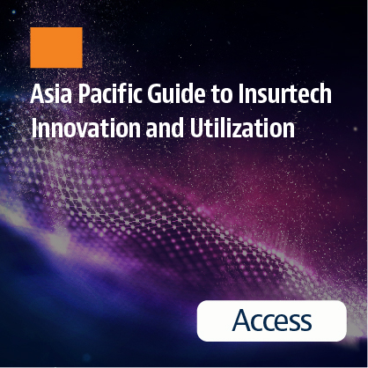
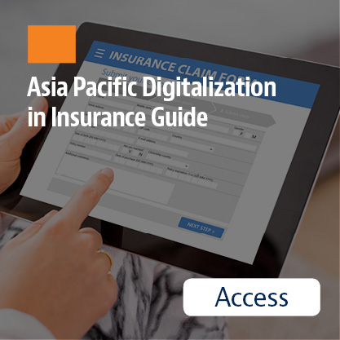
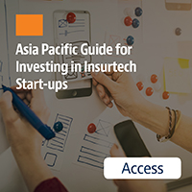
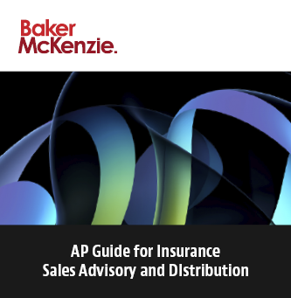
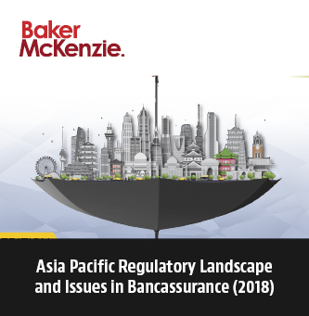
©Copyright © 2024 Baker & McKenzie. All rights reserved. Ownership: This documentation and content (Content) is a proprietary resource owned exclusively by Baker McKenzie (meaning Baker & McKenzie International and its member firms). The Content is protected under international copyright conventions. Use of this Content does not of itself create a contractual relationship, nor any attorney/client relationship, between Baker McKenzie and any person. Non-reliance and exclusion: All Content is for informational purposes only and may not reflect the most current legal and regulatory developments. All summaries of the laws, regulations and practice are subject to change. The Content is not offered as legal or professional advice for any specific matter. It is not intended to be a substitute for reference to (and compliance with) the detailed provisions of applicable laws, rules, regulations or forms. Legal advice should always be sought before taking any action or refraining from taking any action based on any Content. Baker McKenzie and the editors and the contributing authors do not guarantee the accuracy of the Content and expressly disclaim any and all liability to any person in respect of the consequences of anything done or permitted to be done or omitted to be done wholly or partly in reliance upon the whole or any part of the Content. The Content may contain links to external websites and external websites may link to the Content. Baker McKenzie is not responsible for the content or operation of any such external sites and disclaims all liability, howsoever occurring, in respect of the content or operation of any such external websites. Attorney Advertising: This Content may qualify as “Attorney Advertising” requiring notice in some jurisdictions. To the extent that this Content may qualify as Attorney Advertising, PRIOR RESULTS DO NOT GUARANTEE A SIMILAR OUTCOME. Reproduction: Reproduction or copying of the Content on this Site without express written authorization is strictly prohibited.

