  - Africa Competition Guide

Contents
To generate table of contents, right-click here and select Update Field.

An Overview of Competition & Antitrust Regulations and Developments in Africa: 2022
Competition authorities play an important role as champions, advocates and enforcers of competition policy across economies and view competition policy as a key driver of economic growth. Although over the past two years African competition regulators have actively engaged in efforts to address pandemic-related challenges, there has also been a general upward trend in competition policy enforcement across the continent. Matrices used to analyze economic transformation, such as the Bertelsmann Transformation Index, note the existence of comprehensive competition laws that are enforced (to some degree) in at least 46 African jurisdictions. The graph below, by Bertelsmann Transformation Index, denotes the existence of comprehensive competition laws that are strictly enforced, measured on a scale of 1 to 10, where 10 denotes high levels of enforcement. Almost half of the jurisdictions received a score of five or higher, demonstrating robust enforcement across much of the continent. Additionally, a review of historical scores indicates a year-on-year increase in respect of a number of African jurisdictions, with countries such as Eswatini, Ethiopia and Namibia each ranking higher than the previous year.
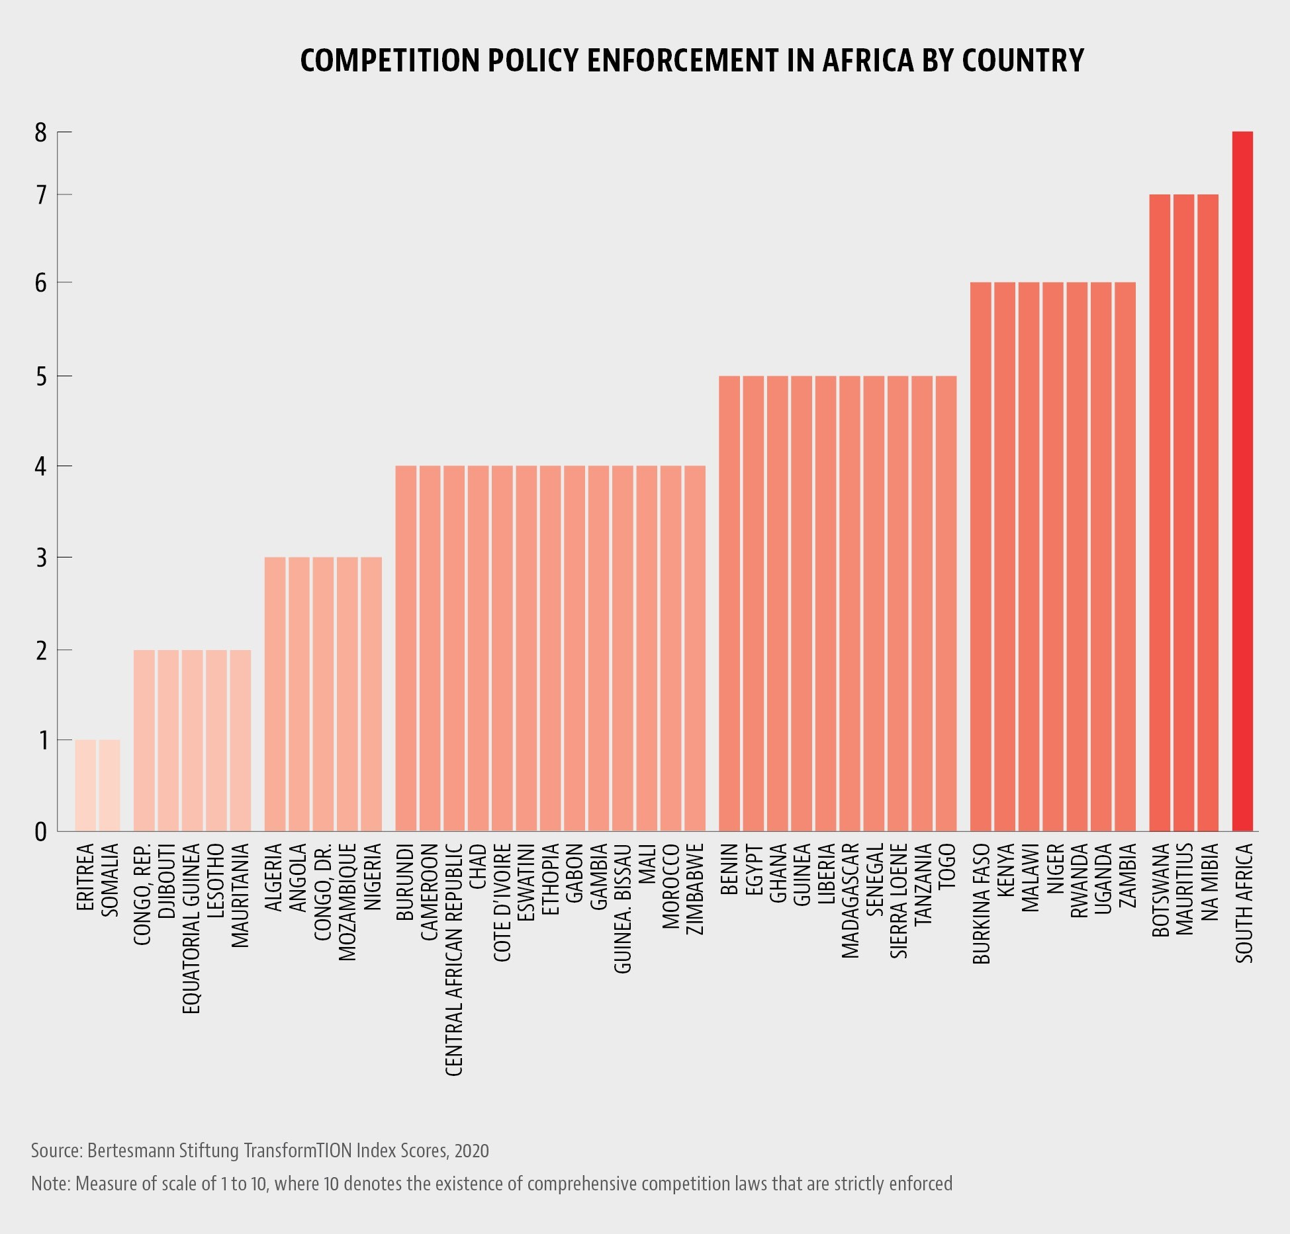
This upward trend in enforcement is highlighted by a number of significant recent developments in competition law regulation around the continent, which draw attention to the continent’s collective enthusiasm in ensuring competition compliance, and its determination in promoting and protecting more effective economies.
Furthermore, a number of African jurisdictions have strengthened their competition and antitrust regimes by way of amendments to existing legislation, the introduction of new laws and regulations, and renewed fervor and political will to enforce existing laws.
This Africa Competition Report (“ACR”) has been a collaborative effort between Baker McKenzie and its Africa Relationship Firms (“ARFs”), covering a detailed analysis and overview of recent developments in competition law enforcement and competition policy in 32 African jurisdictions. This report expands the scope of earlier ACRs, considering not only recent developments in competition law enforcement and competition policy in each of the highlighted jurisdictions but also providing an overview of regulatory and legislative dynamics and challenges in selected markets.
©Copyright © 2024 Baker & McKenzie. All rights reserved. Ownership: This documentation and content (Content) is a proprietary resource owned exclusively by Baker McKenzie (meaning Baker & McKenzie International and its member firms). The Content is protected under international copyright conventions. Use of this Content does not of itself create a contractual relationship, nor any attorney/client relationship, between Baker McKenzie and any person. Non-reliance and exclusion: All Content is for informational purposes only and may not reflect the most current legal and regulatory developments. All summaries of the laws, regulations and practice are subject to change. The Content is not offered as legal or professional advice for any specific matter. It is not intended to be a substitute for reference to (and compliance with) the detailed provisions of applicable laws, rules, regulations or forms. Legal advice should always be sought before taking any action or refraining from taking any action based on any Content. Baker McKenzie and the editors and the contributing authors do not guarantee the accuracy of the Content and expressly disclaim any and all liability to any person in respect of the consequences of anything done or permitted to be done or omitted to be done wholly or partly in reliance upon the whole or any part of the Content. The Content may contain links to external websites and external websites may link to the Content. Baker McKenzie is not responsible for the content or operation of any such external sites and disclaims all liability, howsoever occurring, in respect of the content or operation of any such external websites. Attorney Advertising: This Content may qualify as “Attorney Advertising” requiring notice in some jurisdictions. To the extent that this Content may qualify as Attorney Advertising, PRIOR RESULTS DO NOT GUARANTEE A SIMILAR OUTCOME. Reproduction: Reproduction or copying of the Content on this Site without express written authorization is strictly prohibited.

